Constellation Research

Constellation ShortList™ Badge Usage Guidelines

What is a Constellation ShortList?
The Constellation ShortList™ presents technology vendors relevant to early adopters pursuing digital transformation. Products and vendors included in the document meet the threshold criteria for the category as determined by Constellation Research.

Solutions on the Constellation ShortList™ are selected by Constellation analysts through a research process that includes client inquiries, partner conversations, customer references, vendor selection projects, market share and internal research.

What is a Constellation ShortList badge?
The Constellation ShortList badge is granted by Constellation Research to vendors who have been named in a category of Constellation ShortList effective a specific quarter. Providers who have been named in a Constellation ShortList can add the badge to their website, other online properties, or other marketing materials. This document contains guidelines on the use of the Constellation ShortList badge.

Each Constellation ShortList evaluation will be updated every 180 days as needed.

The current Constellation ShortList badge

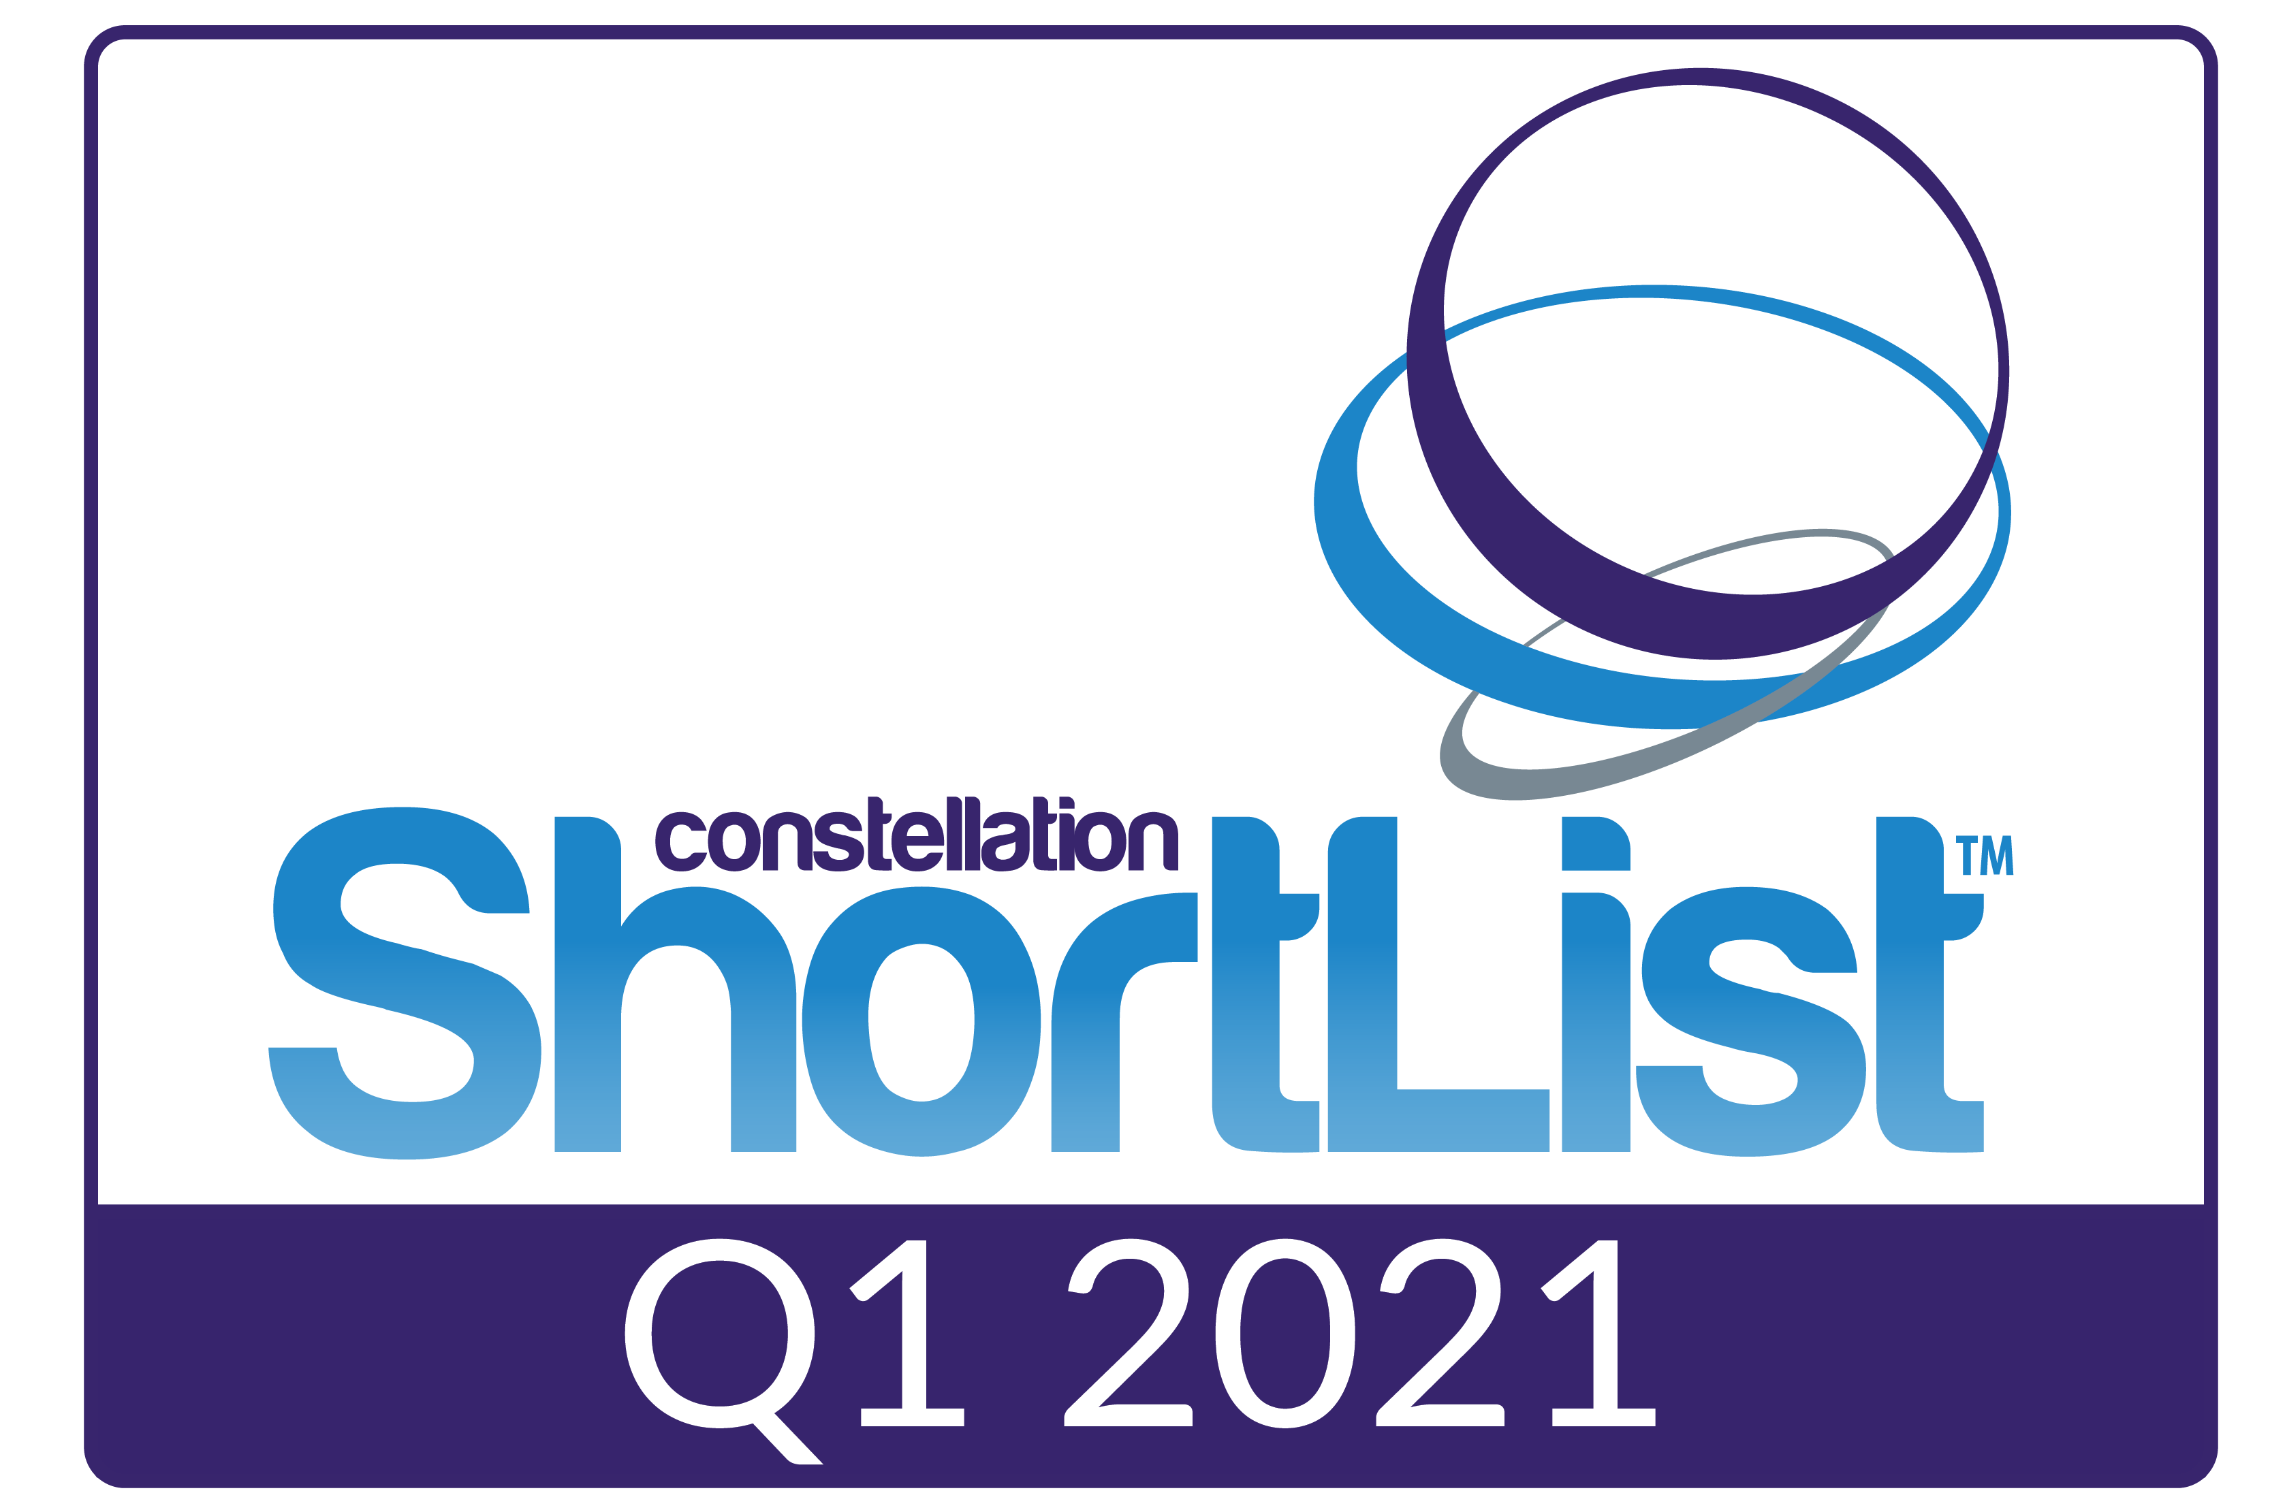

What are the Terms and Guidelines for Badge Usage?
By using the Constellation ShortList badge, you are agreeing to these terms and must follow the guidelines below. Please read these guidelines carefully. The badge may not be used any other way than as specified in these guidelines.

The Constellation ShortList is a trademarked and copyrighted creation belonging to Constellation Research, and that all rights accruing from the use of the mark shall be to the benefit of Constellation Research. The name, logo and each Constellation Shortlist document are protected under the trademark and copyright laws of the United States of America. Any use of same, including in electronic form, must be made only by permission and under the guidelines of Constellation Research.

Failure to comply with the following bade usage guidelines will disqualify the company from using the badge hereafter.

- When using the badge, you must prominently specify the category name and quarter-year date of your applicable Constellation ShortList.

- If you show the badge online or in emails, it must link to its applicable Constellation ShortList web page on the Constellation Research website.

- You can use the badge in your marketing materials to indicate that you've earned the distinction of being named to a Constellation ShortList. Example marketing materials are company website, in the footer of emails, LinkedIn page, and presentation materials for clients. You cannot, however, imitate the badge in any manner in your materials.

- You can resize the badge to fit on your marketing materials and/or website as long as you maintain the aspect ratio and colors of the badge.

- If you are using the badge on any collateral, you must include your own company branding.

- If you are using the badge on a webpage, there must exist a minimum spacing that is no less than 1/2 the height of the badge between each side of the badge and other graphic or textual elements on your webpage.

- Under no circumstances may a firm use the logos of Constellation Research, or any other creative from Constellation Research, without the express written permission of Constellation Research.

- In the event that a future dated version of a Constellation ShortList no longer names you onto its list, your right to use previously dated version of the Constellation ShortList badge is void such that all uses of the badge must cease.

- These guidelines are subject to change without notice, and Constellation Research may withdraw or change these guidelines at any time and for any reason.

However, you agree not to:

- Remove, distort, or alter any element of the badge. For example, you cannot change the colors of the badge.

- Translate the badge or otherwise localize it into any other language.

- Display the badge as the most prominent element on your webpage, or so that it appears larger or more prominent than your own name or logos.

- Incorporate the badge or elements of the badge into your own logos.

- Put the badge on any products or promotional items, such as, but not limited to, reprints, e-prints, plaques, lapel pins or other products.

- Use the badge in any manner that implies a relationship or affiliation with Constellation Research. The badge cannot be used in any way that may indicate that Constellation Research sponsors your company.

- Use the badge in a way that might be reasonably interpreted to suggest editorial content has been authored by or represents the views or opinions of Constellation Research.

- Display the badge on any website that contains or displays adult content, promotes gambling, involves the sale of tobacco or alcohol to persons under 21 years of age, or otherwise violates applicable law or stated Constellation Research editorial policies.

- Display the badge in a manner that is in Constellation Research’s sole opinion misleading, defamatory, infringing, libelous, disparaging, obscene, or otherwise objectionable to Constellation Research.

- Display the badge on a site that violates any law or regulation.

Congratulations on being named to a Constellation ShortList!

For further information or questions, please contact us at ShortList@constellationr.com.

